Types of Dictionaries
# Source: AI Source: Provided by: [Data Path: Persons Table -> ID Column: 1, Name_En Column: Motasem Essam] -> From: [Chatgpt (GPT-4-turbo)] on [7/29/2025]
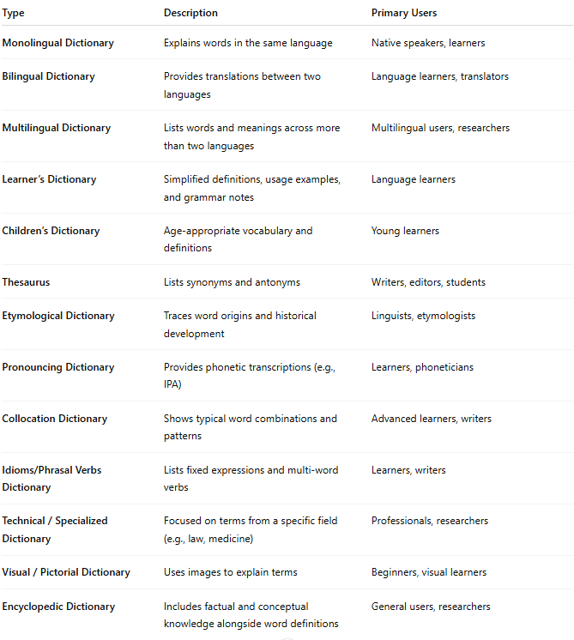
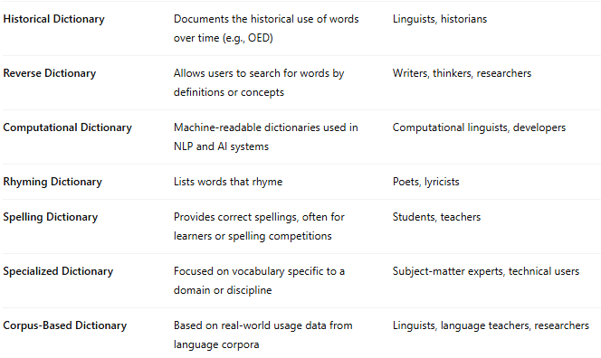
Type | Description | Primary Users
Monolingual Dictionary | Explains words in the same language | Native speakers, learners
Bilingual Dictionary | Provides translations between two languages | Language learners, translators
Multilingual Dictionary | Lists words and meanings across more than two languages | Multilingual users, researchers
Learner’s Dictionary | Simplified definitions, usage examples, and grammar notes | Language learners
Children’s Dictionary | Age-appropriate vocabulary and definitions | Young learners
Thesaurus | Lists synonyms and antonyms | Writers, editors, students
Etymological Dictionary | Traces word origins and historical development | Linguists, etymologists
Pronouncing Dictionary | Provides phonetic transcriptions (e.g., IPA) | Learners, phoneticians
Collocation Dictionary | Shows typical word combinations and patterns | Advanced learners, writers
Idioms/Phrasal Verbs Dictionary | Lists fixed expressions and multi-word verbs | Learners, writers
Technical / Specialized Dictionary | Focused on terms from a specific field (e.g., law, medicine) | Professionals, researchers
Visual / Pictorial Dictionary | Uses images to explain terms | Beginners, visual learners
Encyclopedic Dictionary | Includes factual and conceptual knowledge alongside word definitions | General users, researchers
Historical Dictionary | Documents the historical use of words over time (e.g., OED) | Linguists, historians
Reverse Dictionary | Allows users to search for words by definitions or concepts | Writers, thinkers, researchers
Computational Dictionary | Machine-readable dictionaries used in NLP and AI systems | Computational linguists, developers
Rhyming Dictionary | Lists words that rhyme | Poets, lyricists
Spelling Dictionary | Provides correct spellings, often for learners or spelling competitions | Students, teachers
Specialized Dictionary | Focused on vocabulary specific to a domain or discipline | Subject-matter experts, technical users
Corpus-Based Dictionary | Based on real-world usage data from language corpora | Linguists, language teachers, researchers

